37 *2020 Census Enterprise Architecture and Infrastructure Transition Plan*

4 Current State Architecture

The current state 2020 Census architecture is based on the 2015 National Content Test (NCT) technical

baseline and the infrastructure that supports the ongoing Geographic Programs. This architecture serves

as the starting point for subsequent architecture developments, deployed to support a series of large

scale Census tests planned for 2015-2018 and to support upcoming changes to Geographic Programs

during those years. The 2015 NCT architecture consists of mostly fielded legacy application

enhancements, with some newer application development efforts introduced for test evaluation. The

2015 NCT was selected as a baseline since it was the most current. As a result, the architecture was

based on the needs of the 2015 NCT and the systems available.

The 2015 NCT was used for content testing, testing different contact strategies aimed at optimizing self

response, and testing different approaches for offering in-language materials. The test also included Puerto Rico but did not include Nonresponse Followup (NRFU) or other field operations. Note that there is a separate geographic programs infrastructure that is also undergoing evolution simultaneously, and where relevant, the linkages between the Current State changes and geographic programs will be noted.

4.1 Business Architecture The information flows among the primary business operations for the 2015 NCT are highlighted in the

Figure 4-1. Major interactions and flows are shown via the arrows in the diagram and the key external interfaces are depicted via labeled icons.

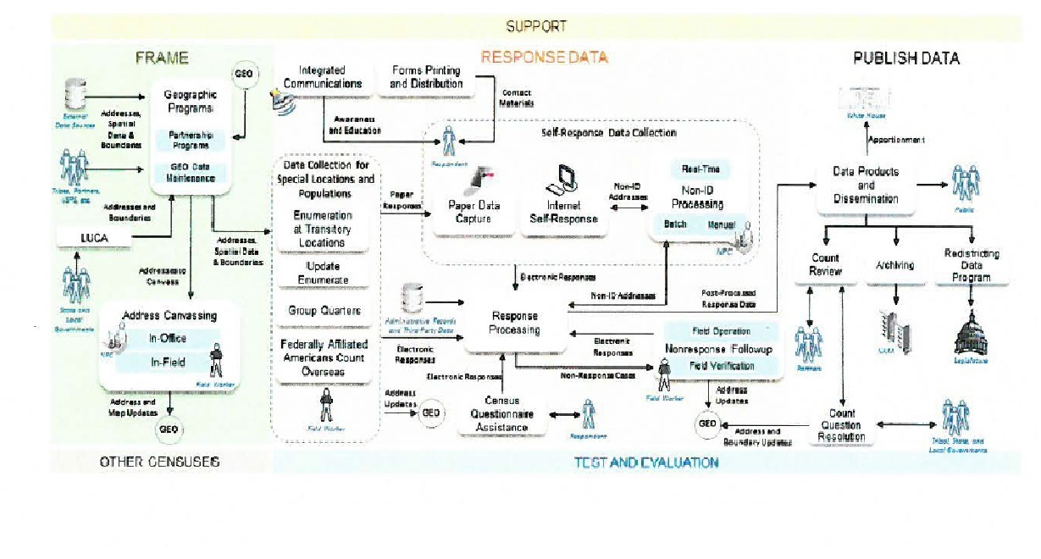

Figure 4-1 High-Level Integration of Operations for 2015 NCT

The operation that was primarily being informed by the 2015 NCT was the Content Forms and Design (CFD) and the contact strategy which is currently developed in Internet Self-Response (ISR), but executed through Forms Printing and Distribution (FPD). Refer to Appendix K: Architecture Transition

Table for a complete list of operations that supported this test. The other operations that participated in this test were implemented to support this test, but were not the focus of the test in terms of answering the design questions.

The 2015 NCT includes multiple operational areas that collectively provide the anticipated capabilities

that map to the end-to-end survey lifecycle and are grouped into five categories: support, frame

development, response data collection, disseminate data, and test, evaluation, and other censuses.

* The Support segment addresses the needs for HR, IT, and Infrastructure support services of the 2020 Census. Support is comprised of the program management, survey engineering, and infrastructure operational categories.
* The Frame development segment entails activities within the geographic programs, LUCA, and Re-Engineered Address Canvassing. These activities support the task of developing administrative records frame, geographic delineations, and address canvassing. LUCA was not part of the 2015 NCT, although it is part of the Geographic Programs.
* The Response Data Collection segment is the largest segment within the 2020 Census Architecture where thirteen distinct operations work together to achieve the data/response information collection goals. The response data collection segment includes a multitude of enterprise and non-enterprise systems, the majority of which are scoped within CEDCaP.
* The Disseminate data segment is responsible for activities such as accurate production, review, and dissemination of the data collected by the response data collection segment and shared with the stakeholders. The disseminate data segment was not involved in the 2015 NCT.
* The test, evaluation, and other censuses segments include five operational areas with activities that address coverage measurements, matching, follow-ups of the housing units and interviews, enumerations, and experiments. The test, evaluation, and other censuses segments were not involved in the 2015 NCT.